ASSIGNMENT – 26.12.2023 YAZHINI S

PYSPARK FUNCTIONS AND COMMANDS

🡪Using ceil function : It round off the given value and take the smallest number.

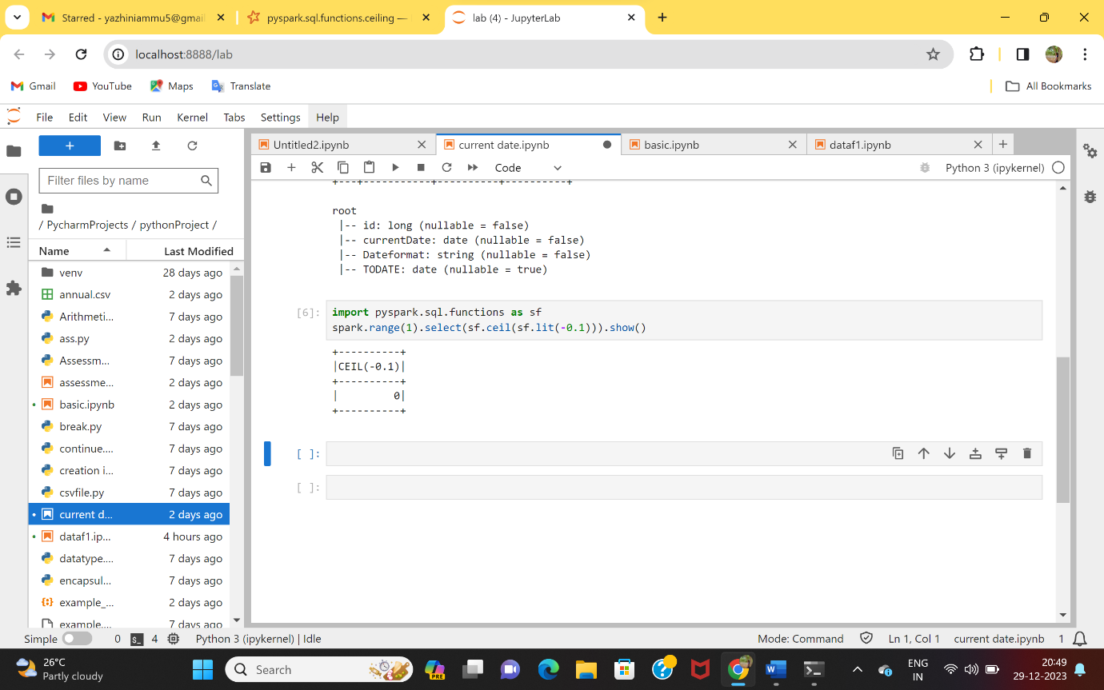

🡪Creating DataFrame

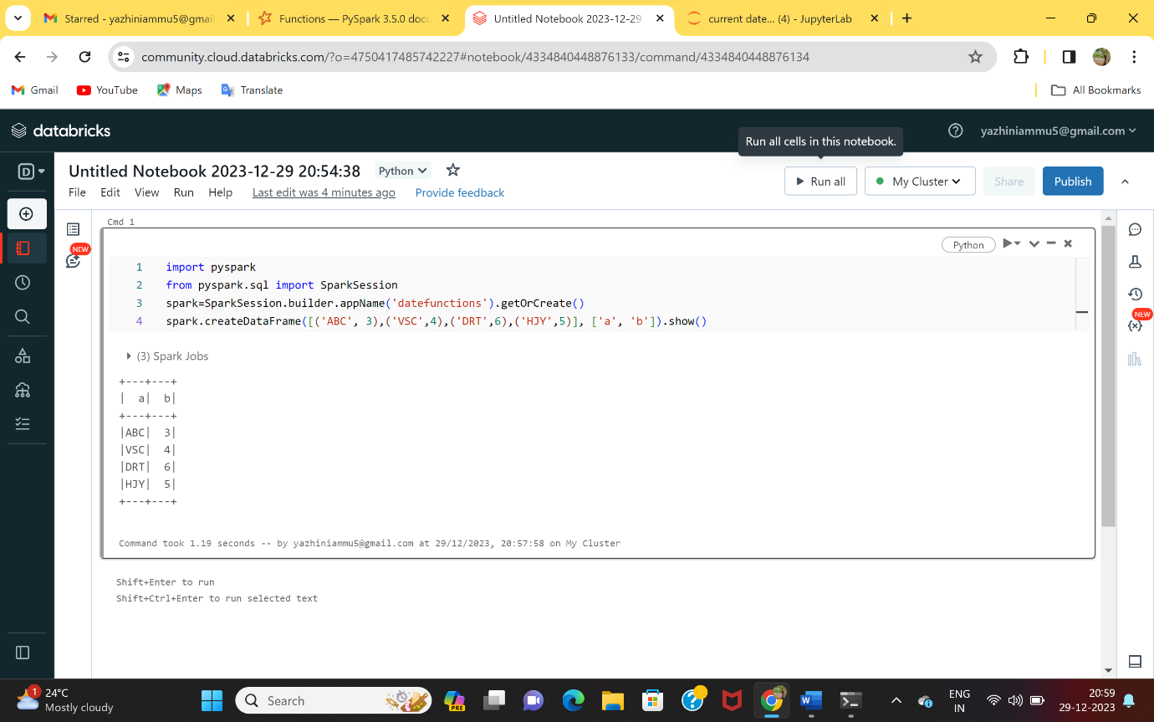

🡪Using range : Allocates number of rows based on the value given.

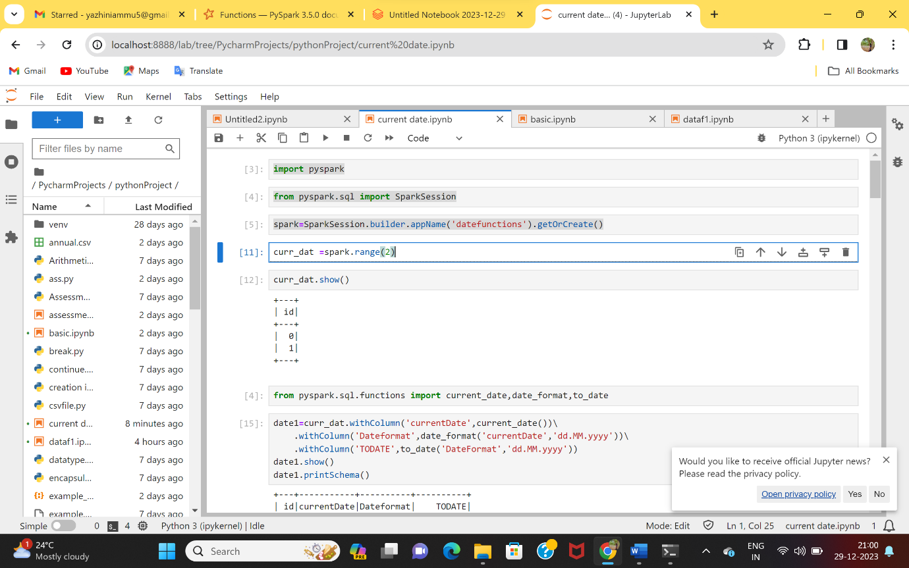

🡪Using withColumn : It is used to add a column to the table.

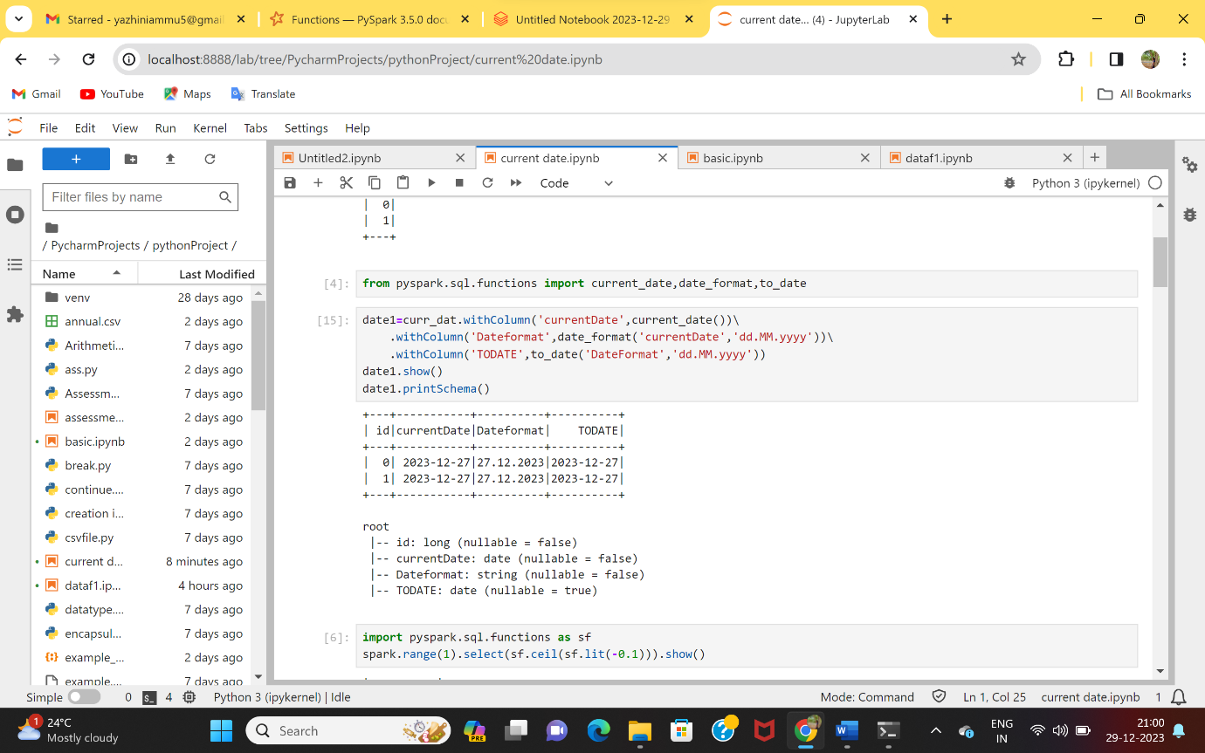

🡪Using type : Gives the name of the DataFrame used.

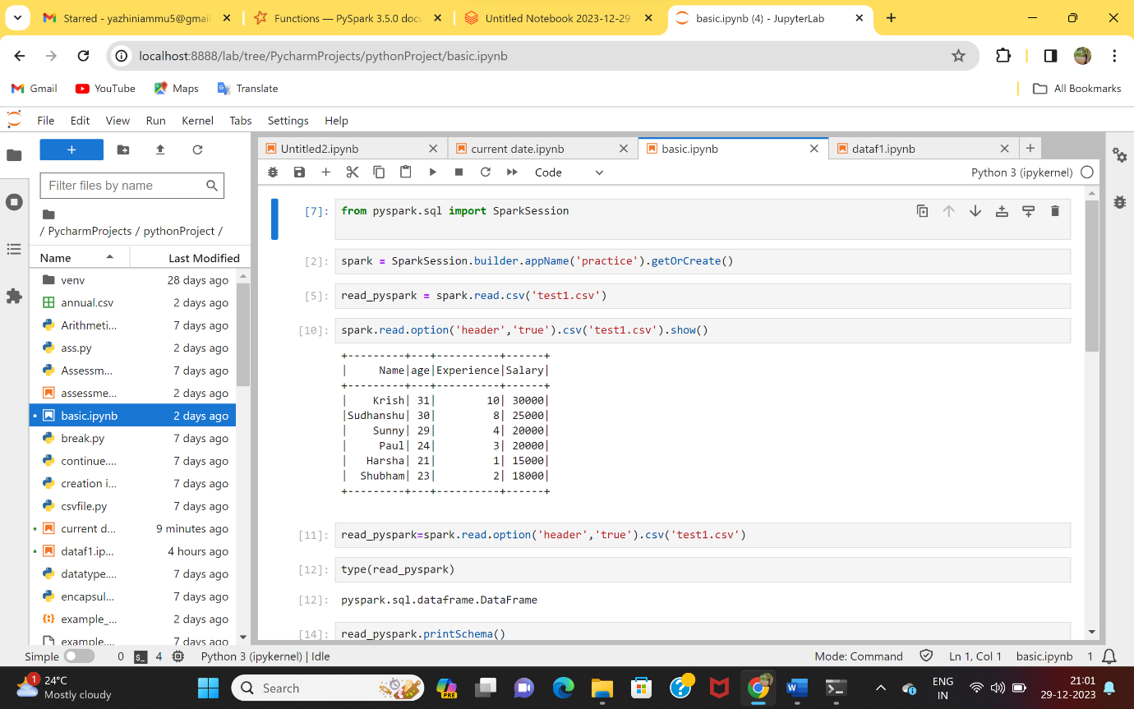

🡪Using printSchema : Gives the datatypes of the table taken.

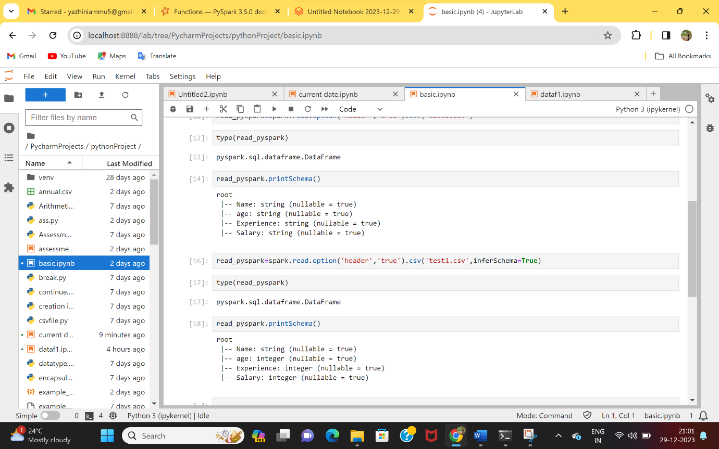

🡪Using select : It selects the particular column that is given.

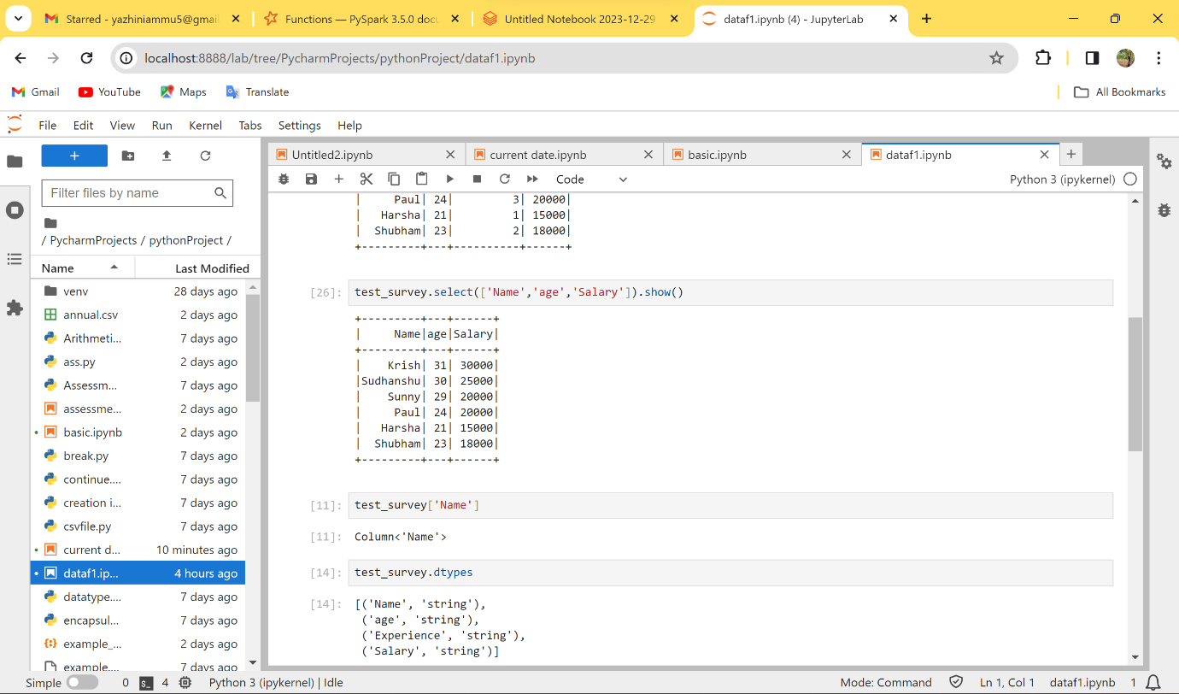

🡪Using describe : it defines the mean, count, minimun value and maximum value etc., of the given table.

